Fall 2018

CSE221 Quiz: 1

Total Marks: 20

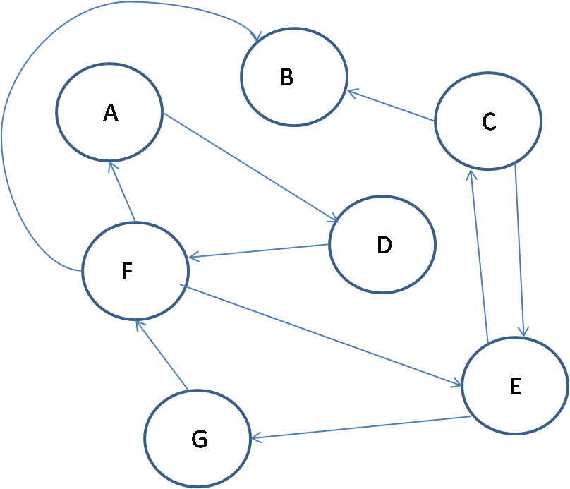

1. For the given graph draw the corresponding Adjacency List. [3]
2. If you are to count the number of connections using the data structure above what would be your time complexity. Explain your answer. [5]
3. Find the back edges of the graph? What do back edges represent? [5 + 2]
4. What do you understand by upper bound? Explain using curves/equation. [2+3]